ABSTRACT
Stress has become one of the most significant challenges affecting individuals in modern society, particularly due to rapid technological advancement, increased screen time, work pressure, and lifestyle imbalance. High stress levels negatively impact mental health, physical well-being, productivity, and overall quality of life. Traditional stress assessment methods rely on questionnaires, psychological evaluations, or self-reported surveys, which are often subjective, time-consuming, and inconsistent. There is a growing need for automated and data-driven systems that can estimate stress levels objectively based on behavioral and lifestyle indicators.

This project presents a Stress Level Prediction System developed using deep learning techniques and deployed as a Streamlit web application. The system predicts an individual’s stress level based on parameters such as age, gender, job type, social media usage, notification frequency, working hours, sleep duration, screen time before sleep, and breaks during work. These features collectively represent physical, mental, and behavioral factors influencing stress.

A trained deep learning model processes the scaled input data and outputs a numerical stress level score. The web-based interface allows users to easily input their daily habits and instantly receive stress predictions. This project demonstrates how artificial intelligence and deep learning can be applied effectively in mental health analytics and stress monitoring systems.

INTRODUCTION
Stress is a natural psychological and physiological response to challenges and demands. While moderate stress can be motivating, prolonged or excessive stress leads to serious health issues such as anxiety, depression, cardiovascular diseases, and reduced work performance. In today’s digital environment, factors such as excessive screen exposure, constant notifications, long working hours, and poor sleep habits significantly contribute to stress.
Traditional stress evaluation methods are largely subjective and depend on clinical assessments or self-reported questionnaires. These methods are not scalable and cannot provide real-time insights into an individual’s stress condition. With the advancement of machine learning and deep learning, it has become possible to analyze behavioral data and predict stress levels accurately.
This project introduces a deep learning-based stress prediction system that estimates stress levels using lifestyle and work-related parameters. By deploying the model through Streamlit, the system becomes accessible as an interactive web application. The project highlights the importance of data-driven mental health assessment and demonstrates the practical use of AI in stress analysis.
This study analyzes the relationship between sleep quality, workload, and stress, providing empirical evidence for stress modeling

LITERACY SURVEY:-

Stress and Lifestyle Factors
Author(s): Lazarus and Folkman
Year: 1984
This work introduces the transactional model of stress and coping, emphasizing how lifestyle and environmental factors influence stress responses.

Machine Learning in Mental Health Assessment
Author(s): Shatte et al.
Year: 2019
The authors review machine learning applications in mental health, highlighting predictive models for stress and emotional well-being.

Impact of Sleep and Workload on Stress
Author(s): Åkerstedt et al.
Year: 2014
This study analyzes the relationship between sleep quality, workload, and stress, providing empirical evidence for stress modeling.

Deep Learning for Behavioral Prediction
Author(s): Goodfellow et al.
Year: 2016
The book explains deep learning techniques and their ability to model complex behavioral patterns, forming the basis for stress prediction systems.

Rapid Deployment of ML Applications Using Streamlit
Author(s): Streamlit Inc.
Year: 2019
This reference presents Streamlit as a framework for deploying machine learning models with interactive web interfaces.

SYSTEM ANALYSIS

3.1 EXISTING SYSTEM
Existing stress assessment systems rely mainly on psychological questionnaires, interviews, and clinical evaluations. These methods are subjective and depend heavily on user honesty and emotional state at the time of assessment. They are also time-consuming and require trained professionals.
Some digital wellness applications track limited parameters such as screen time or sleep but fail to combine multiple factors into a unified stress assessment. These tools lack predictive capabilities and often provide generic insights rather than personalized analysis.
Traditional systems are not scalable and cannot adapt to changing behavioral patterns. They also do not provide quantitative stress scores based on data analysis. These disadvantages highlight the need for an automated, intelligent, and data-driven stress prediction system.

3.2 DISADVANTAGES

1. Data Quality and Labeling Issues

Psychological states (e.g., anxiety, depression, loneliness) are complex and subjective, yet ML/DL models often rely on self-reported surveys, proxy labels, or inferred behaviors, which may be inaccurate, inconsistent, or biased. Poor-quality labels lead to unreliable predictions.

2. Ethical and Privacy Concerns

Analyzing social media data raises serious privacy, consent, and surveillance issues. Users may not be aware their posts, messages, or interactions are being used to infer mental health conditions, potentially violating ethical standards and data protection regulations.

3. Bias and Lack of Representativeness

Social media users are not representative of the general population. ML/DL models may inherit demographic, cultural, and socioeconomic biases, leading to skewed results and unfair conclusions especially for underrepresented groups.

4. Limited Interpretability of Deep Learning Models

Deep learning models often function as “black boxes”, making it difficult for psychologists, clinicians, and policymakers to understand why a particular prediction was made. This lack of explainability limits trust and real-world applicability.

3.3 PROPOSED SYSTEM
The proposed system introduces a deep learning-based approach to stress level prediction. By analyzing multiple lifestyle and work-related parameters, the system captures complex interactions that contribute to stress.
The Streamlit-based interface ensures ease of use and accessibility. Users can input their daily habits and instantly receive stress level predictions. The use of a scaler ensures consistent preprocessing and improved prediction accuracy.

3.4 ADVANTAGES :-
Machine Learning and Deep Learning
- Early Detection of Mental Health Risks
Machine learning and deep learning models can identify early signs of stress, anxiety, depression, or emotional imbalance from social media usage patterns, enabling timely intervention.
- Handling Large and Complex Data
Social media generates vast amounts of structured and unstructured data. ML and DL techniques efficiently analyze large datasets, including text, images, and behavioral patterns, which are difficult to process manually.
- Improved Prediction Accuracy
Deep learning models capture complex, non-linear relationships between social media behavior and psychological states, resulting in higher accuracy compared to traditional statistical methods.
- Real-Time Monitoring
ML-based systems can continuously monitor user behavior and update psychological assessments in real time, allowing dynamic and up-to-date mental health analysis.
- Personalized Insights
These models provide personalized psychological assessments based on individual usage patterns, helping tailor mental health recommendations and interventions.
- Automation and Scalability
Once trained, ML and DL systems can automatically analyze data for thousands or millions of users, making the approach scalable and cost-effective.
- Objective and Data-Driven Analysis
Machine learning reduces human bias by relying on data-driven insights rather than subjective self-reports or manual evaluations.
- Multimodal Data Analysis
Deep learning can integrate multiple data types such as text posts, emojis, images, engagement metrics, and time-based activity, offering a holistic psychological assessment.
- Support for Mental Health Research
The insights generated help psychologists and researchers better understand the relationship between social media usage and mental health trends across different populations.
- Decision Support for Policy and Well-being Applications
The results can guide institutions, educators, and healthcare professionals in designing mental health awareness programs and digital well-being policies.

SYSTEM STUDY
FEASIBILITY STUDY
The feasibility of the project is analyzed in this phase and business proposal is put forth with a very general plan for the project and some cost estimates. During system analysis the feasibility study of the proposed system is to be carried out. This is to ensure that the proposed system is not a burden to the company. For feasibility analysis, some understanding of the major requirements for the system is essential.
Three key considerations involved in the feasibility analysis are,
- ECONOMICAL FEASIBILITY
- TECHNICAL FEASIBILITY
- SOCIAL FEASIBILITY
ECONOMICAL FEASIBILITY
This study is carried out to check the economic impact that the system will have on the organization. The amount of fund that the company can pour into the research and development of the system is limited. The expenditures must be justified. Thus the developed system as well within the budget and this was achieved because most of the technologies used are freely available. Only the customized products had to be purchased.

TECHNICAL FEASIBILITY
This study is carried out to check the technical feasibility, that is, the technical requirements of the system. Any system developed must not have a high demand on the available technical resources. This will lead to high demands on the available technical resources. This will lead to high demands being placed on the client. The developed system must have a modest requirement, as only minimal or null changes are required for implementing this system.

SOCIAL FEASIBILITY
The aspect of study is to check the level of acceptance of the system by the user. This includes the process of training the user to use the system efficiently. The user must not feel threatened by the system, instead must accept it as a necessity. The level of acceptance by the users solely depends on the methods that are employed to educate the user about the system and to make him familiar with it. His level of confidence must be raised so that he is also able to make some constructive criticism, which is welcomed, as he is the final user of the system.

1.Software Requirements
Software Component | Version / Details
Operating System | Windows 11or later / Linux /macOS
Python Interpreter | Python 3.7 or higher
Required Python Libraries | - scikit-learn (for ML model)
 | - joblib (for model serialization)
- numpy (for numerical operations)
-tensorflow(for DL)
 | - tkinter (for GUI; usually pre-installed with Python)
IDE / Editor | Any Python IDE or text editor (e.g., VS Code, PyCharm, IDLE)

2. Hardware Requirements
Component | Minimum Specification | Recommended Specification
Processor (CPU) | Intel Core i5 or equivalent | Intel Core i7 or better
RAM | 8 GB | 16 GB or more
Storage | At least 500 MB free disk space | At least 1 GB free disk space
Display | Minimum resolution 1024 x 768 | Full HD resolution (1920 x 1080)
Input Device | Keyboard and Mouse | Keyboard and Mouse

7.1 INPUT AND OUTPUT DESIGN
INPUT DESIGN
The input design is the link between the information system and the user. It comprises the developing specification and procedures for data preparation and those steps are necessary to put transaction data in to a usable form for processing can be achieved by inspecting the computer to read data from a written or printed document or it can occur by having people keying the data directly into the system. The design of input focuses on controlling the amount of input required, controlling the errors, avoiding delay, avoiding extra steps and keeping the process simple. The input is designed in such a way so that it provides security and ease of use with retaining the privacy. Input Design considered the following things:
- What data should be given as input?
- How the data should be arranged or coded?
- The dialog to guide the operating personnel in providing input.
- Methods for preparing input validations and steps to follow when error occur.

OBJECTIVES
1.Input Design is the process of converting a user-oriented description of the input into a computer-based system. This design is important to avoid errors in the data input process and show the correct direction to the management for getting correct information from the computerized system.
2. It is achieved by creating user-friendly screens for the data entry to handle large volume of data. The goal of designing input is to make data entry easier and to be free from errors. The data entry screen is designed in such a way that all the data manipulates can be performed. It also provides record viewing facilities.
3.When the data is entered it will check for its validity. Data can be entered with the help of screens. Appropriate messages are provided as when needed so that the user will not be in maize of instant. Thus the objective of input design is to create an input layout that is easy to follow

OUTPUT DESIGN
A quality output is one, which meets the requirements of the end user and presents the information clearly. In any system results of processing are communicated to the users and to other system through outputs. In output design it is determined how the information is to be displaced for immediate need and also the hard copy output. It is the most important and direct source information to the user. Efficient and intelligent output design improves the system’s relationship to help user decision-making.
1. Designing computer output should proceed in an organized, well thought out manner; the right output must be developed while ensuring that each output element is designed so that people will find the system can use easily and effectively. When analysis design computer output, they should Identify the specific output that is needed to meet the requirements.
2.Select methods for presenting information.
3.Create document, report, or other formats that contain information produced by the system.
The output form of an information system should accomplish one or more of the following objectives.
- Convey information about past activities, current status or projections of the
- Future.
- Signal important events, opportunities, problems, or warnings.
- Trigger an action.
- Confirm an action.

SYSTEM DESIGN

8.1 ARCHITECTURE

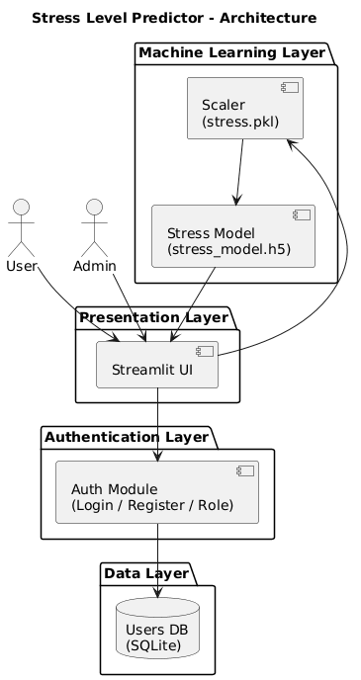

8.2 UML DIAGRAMS

Use case Diagram

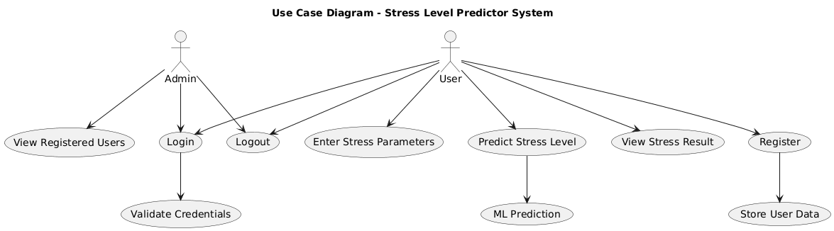

Class Diagram

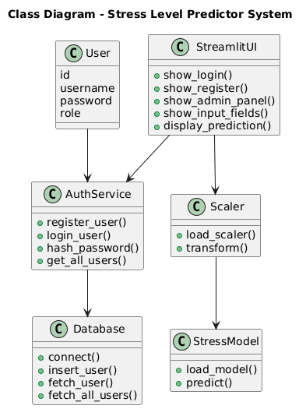

Sequence Diagram

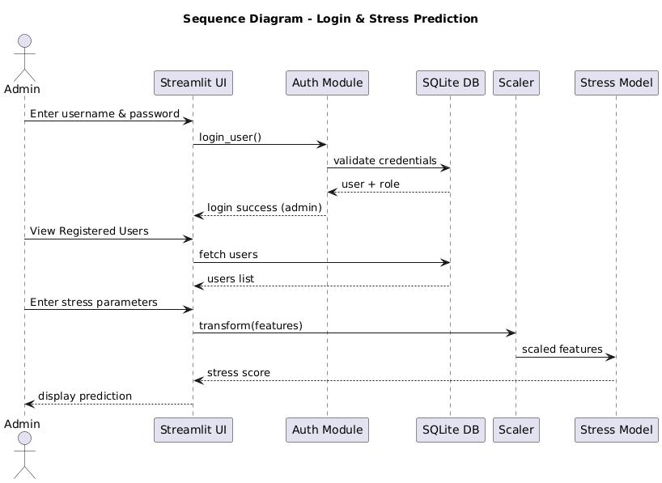

Data Flow Diagram

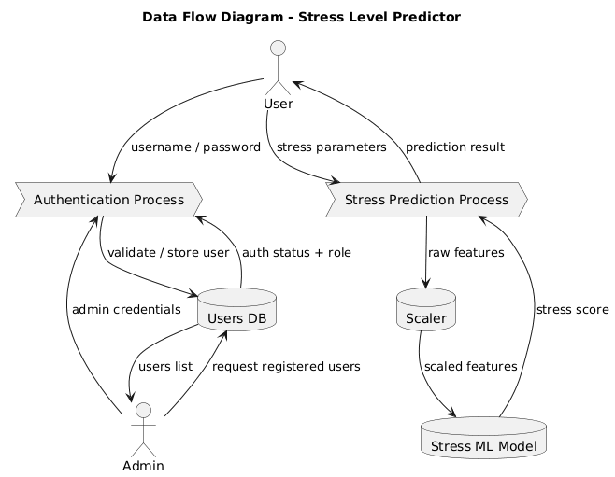

Activity Diagram

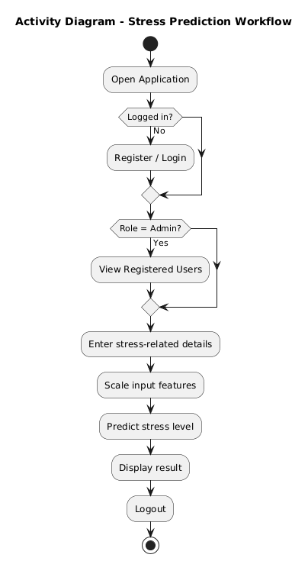

SYSTEM IMPLEMENTATION
The Stress Level Prediction System is implemented using Python due to its flexibility, readability, and strong support for machine learning and deep learning frameworks. Python enables efficient data processing, model training, and deployment within a single integrated environment, making it suitable for large-scale psychological data analysis.
The user interface of the system is developed using Streamlit, a lightweight web framework that allows real-time interaction between the user and the prediction system. The interface enables users to enter lifestyle and work-related parameters such as sleep duration, working hours, and activity levels, and view prediction results instantly.
User-provided data is initially processed through a data preprocessing module. This module is responsible for handling missing values, encoding categorical variables into numerical representations, and preparing the dataset for further analysis. Proper preprocessing ensures that the data is compatible with machine learning algorithms.
After encoding, the input features are normalized using a Standard Scaler. Feature scaling is an essential step to maintain uniform data distribution and to prevent features with larger values from dominating the learning process, especially in regression and neural network models.
The system incorporates multiple predictive models, including Linear Regression, Random Forest Regression, and a Deep Neural Network. Linear Regression serves as a baseline model, while Random Forest Regression captures non-linear relationships. The deep learning model provides enhanced prediction accuracy by learning complex patterns.
Each model is trained using historical stress-related data. During training, the models learn relationships between input features and stress levels by minimizing prediction errors using appropriate optimization techniques. Model performance is evaluated to ensure reliable prediction results.
Once training is completed, the trained models and preprocessing components are saved as serialized files. This approach allows the system to reuse trained models during real-time prediction without retraining, improving efficiency and reducing computational overhead.
During system execution, the saved models and scalers are loaded into memory. When the user submits input data, it is passed through the same preprocessing pipeline used during training, ensuring consistency between training and deployment phases.
The processed input data is then fed into the selected prediction model, which generates the stress level output. The predicted stress value is computed based on learned patterns from the dataset and returned to the application for visualization.
Finally, the predicted stress level is displayed to the user through the Streamlit interface in a clear and understandable format. The overall implementation ensures accuracy, scalability, and ease of use, making the system suitable for real-time psychological stress assessment and decision-support applications.

Software Environment
Machine Learning
Tom Mitchell states machine learning as “A computer program is said to learn from experience and from some tasks and some performance on, as measured by, improves with experience”. Machine Learning is combination of correlations and relationships, most machine learning algorithms in existence are concerned with finding and/or exploiting relationship between datasets. Once Machine Learning Algorithms can pinpoint on certain correlations, the model can either use these relationships to predict future observations or generalize the data to reveal interesting patterns. In Machine Learning there are various types of algorithms such as Regression, Linear Regression, Logistic Regression, Naive Bayes Classifier, Bayes theorem, KNN (K-Nearest Neighbor Classifier), Decision Tress, Entropy, ID3, SVM (Support Vector Machines), K-means Algorithm, Random Forest and etc.,
The name machine learning was coined in 1959 by Arthur Samuel. Machine learning explores the study and construction of algorithms that can learn from and make predictions on data Machine learning is closely related to (and often overlaps with) computational statistics, which also focuses on prediction-making through the use of computers. It has strong ties to mathematical optimization, which delivers methods, theory and application domains to the field. Machine learning is sometimes conflated with data mining, where the latter subfield focuses more on exploratory data analysis and is known as unsupervised learning.
Within the field of data analytics, machine learning is a method used to devise complex models and algorithms that lend themselves to prediction; in commercial use, this is known as predictive analytics. These analytical models allow researchers, data scientists, engineers, and analysts to "produce reliable, repeatable decisions and results" and uncover "hidden insights" through learning from historical relationships and trends in the data.

Machine learning tasks Machine learning tasks are typically classified into several broad categories:
Supervised learning: The computer is presented with example inputs and their desired outputs, given by a "teacher", and the goal is to learn a general rule that maps inputs to outputs. As special cases, the input signal can be only partially available, or restricted to special feedback.
Semi-supervised learning: The computer is given only an incomplete training signal: a training set with some (often many) of the target outputs missing.
Active learning: The computer can only obtain training labels for a limited set of instances (based on a budget), and also has to optimize its choice of objects to acquire labels for. When used interactively, these can be presented to the user for labelling.
Unsupervised learning: No labels are given to the learning algorithm, leaving it on its own to find structure in its input. Unsupervised learning can be a goal in itself (discovering hidden patterns in data) or a means towards an end (feature learning).
Reinforcement learning: Data (in form of rewards and punishments) are given only as feedback to the program's actions in a dynamic environment, such as driving a vehicle or playing a game against an opponent.

Benefits of Machine Learning:
- Achieve economies of scale – increase volume output or productivity with fewer people. Your cost per unit, project or product plummets.
- Reduce spending on technology infrastructure. Maintain easy access to your information with minimal upfront spending. Pay as you go (weekly, quarterly or yearly), based on demand.
- Globalize your workforce on the cheap. People worldwide can access the cloud, provided they have an Internet connection.
- Streamline processes. Get more work done in less time with less people.
- Reduce capital costs. There’s no need to spend big money on hardware, software or licensing fees.
- Improve accessibility. You have access anytime, anywhere, making your life so much easier!
- Monitor projects more effectively. Stay within budget and ahead of completion cycle times.
- Less personnel training is needed. It takes fewer people to do more work on a cloud, with a minimal learning curve on hardware and software issues.
- Minimize licensing new software. Stretch and grow without the need to buy expensive software licenses or programs.
- Improve flexibility. You can change direction without serious “people” or “financial” issues at stake.
Advantages:
- Price: Pay for only the resources used.
- Security: Cloud instances are isolated in the network from other instances for improved security.
- Performance: Instances can be added instantly for improved performance. Clients have access to the total resources of the Cloud’s core hardware.
- Scalability: Auto-deploy cloud instances when needed.
- Uptime: Uses multiple servers for maximum redundancies. In case of server failure, instances can be automatically created on another server.
- Control: Able to login from any location. Server snapshot and a software library lets you deploy custom instances.
- Traffic: Deals with spike in traffic with quick deployment of additional instances to handle the load.
Python
Python is high level language and it is also integrated version of the program. Python is an object-oriented approach and its main aim to help programmers to write the code clearly, logical code for small and large scale of project.
Pytrhon is dynamically typed and garbage collected it also support multiple programming and it is both procedure and object oriented and also functional programming. And structural programming also supported. It has many built in function it also supports filter, map and reduce function. All the machine learning algorithm and the libraries are being supported by the python programming language. Python also support list, dict, sets and other generators. Python code can be run in different platform such as anaconda, PyCharm etc.
The main goal of this programing language is as follows:

• Python is simple, object-oriented programming language.
• The language and implementation should provide support for software engineering principles such as strong type library preset for different machine learning algorithm, and all other algorithm in simple manner.
• Coding will be smooth in python and the data analysis can be easily done in python.
This is so much so to the point where we now have modules and APIs at our disposal, and you can engage in machine learning very easily without almost any knowledge at all of how it works. With the defaults from Scikit-learn, you can get 90-95% accuracy on many tasks right out of the gate. Machine learning is a lot like a car, you do not need to know much about how it works in order to get an incredible amount of utility from it.
Despite the apparent age and maturity of machine learning, I would say there's no better time than now to learn it, since you can actually use it. Machines are quite powerful, the one you are working on can probably do most of this series quickly. Data is also very plentiful lately.

Python Technology
Python technology is both a programming language and a platform.
The python Programming Language
THE PYTHON PROGRAMMING LANGUAGE IS A HIGH-LEVEL LANGUAGE THAT CAN BE CHARACTERIZED BY ALL OF THE FOLLOWING BUZZWORDS:

    - Simple
    - Architecture neutral
    - Object oriented
    - Portable
    - Distributed
    - High performance
    - Interpreted
    - Multithreaded
    - Robust
    - Dynamic
    - Secure

With most programming languages, you either compile or interpret a program so that you can run it on your computer. The Python programming language is unusual in that a program is both compiled and interpreted. With the compiler, first you translate a program into an intermediate language called Python byte codes —the platform-independent codes interpreted by the interpreter on the Python platform. The interpreter parses and runs each Python byte code instruction on the computer. Compilation happens just once; interpretation occurs each time the program is executed. The following figure illustrates how this works.
FEATURES OF MACHINE LEARNING
• It is nothing but automating the Automation.
• Getting computers to program themselves.
• Writing Software is bottleneck.
• Machine leaning models involves machines learning from data without the help of humans or any kind of human intervention.
• Machine Learning is the science of making of making the computers learn and act like humans by feeding data and information without being explicitly programmed.

• Machine Learning is totally different from traditionally programming, here data and output is given to the computer and in return it gives us the program which provides solution to the various problems. Below is the figure.
Traditional Programming vs Machine Learning
• Machine Learning is a combination of Algorithms, Datasets, and Programs.
• There are Many Algorithms in Machine Learning through which we will provide us the exact solution in predicting the disease of the patients.
• How Does Machine Learning Works?
• Solution to the above question is Machine learning works by taking in data, finding relationships within that data and then giving the output.
Machine Learning Model

• There are various applications in which machine learning is implemented such as Web search, computing biology, finance, e-commerce, space exploration, robotics, social networks, debugging and much more.
• There are 3 types of machine learning supervised, unsupervised, and reinforcement.
BENEFITS OF PYTHON
• Presence of Third-Party Modules
• Extensive Support Libraries
• Open Source and Community Development
• Learning Ease and Support Available
• User-friendly Data Structures
• Productivity and Speed
• Highly Extensible and Easily Readable Language.

Anaconda
Anaconda is free and open-source distribution of the Python and R programming languages for scientific computing (data science, machine Learning applications, Large- scale data processing, predictive analytics, etc.), that aims to simplify package management and deployment. It is developed and maintained by Anaconda, Inc. The distribution incudes data-science packages suitable for Windows, Linux, and macOS. Packaged versions are required and are managed by the package management system anaconda. This package manager was spun out as a separate open-source package as it ended up being useful on its own and for other things than Python. There is also a small, bootstrap version of Anaconda called Miniconda, which includes only conda, Python, the packages they depends on, and a small number of other packages.
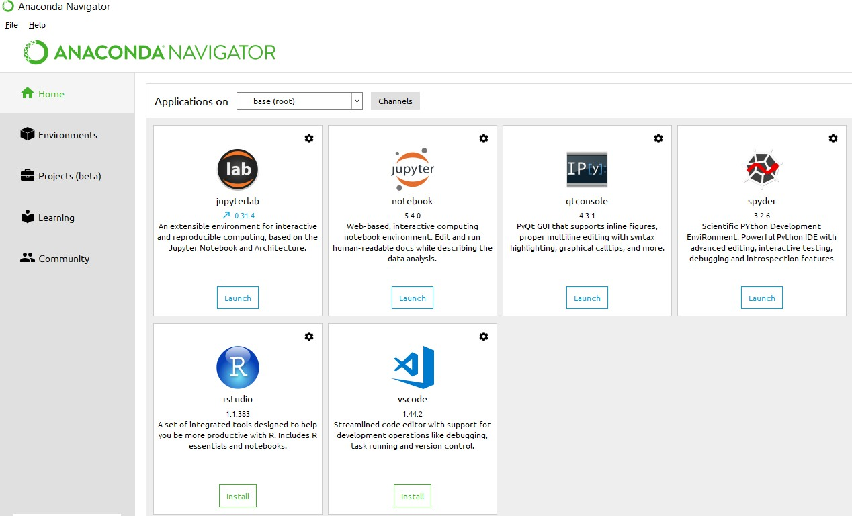
Anaconda Console

Jupyter notebook
Jupiter Notebook or so called IPython Notebook is an interactive web based computational mean for starting with Jupiter Notebook documents. The term notebook itself is a huge entity to represent the integration with different entity sets. JSON is the main document form from the same for the execution which follows the brief on the schema and the input and output means. It has high integration with several language set and has various flexibilities with the choices. The extension used for the same is “.ipynb” which runs in this platform. It’s an open-source software package with interactive communication means. It has it’s open standards for the same. It’s an open community best for budding programmers . The flexibility of the same is phenomenon and splendidly done the configuration and integration of the same is simplest and easy on hold so that no prior distortion is generated and the efficiency of the same is measured through out any system of choice.
It’s the best software sets that been used across cross for designing and developing of the products and support wide help support. Not only to that, it provides scalability in the code and the deployment of the same. Various Language can be changed and the project can be undertaken on the same. The created notebook files can be shared and stored in various means for further utilization. It supports cultivated and interactive output sets. Easily crossed over for graphing, plotting and visualizing of the elements. Data Integration of the same is to it’s best. The integration of big data and it can process chunks of values in an approx. time which gives a better performance and the higher computational means. Various works on data like cleaning, cleansing, transforming modeling and visualizing can be done by the same

Machine learning is the ability that gives the computer to learn without being explicitly programmed. There are two types of machine learning:
Supervised Learning: supervised learning is the learning of the labelled data. It is the types of machine learning that maps the input and output based on the examples input-output pairs. In supervised learning each training data having pairs of input and desired outputs values. Supervised learning algorithm analyzes the training data and produces a function which can be used for mapping of new data.

Fig 2.1 Supervised Learning The output to solve the supervised learning algorithm are as:
• Determine the types of data, before doing anything else the user should understand which types of data set is to be used for training the data.
• Gathered the training data sets either in form of human experts or from measurements.

• Determine the feature of inputs from the learned data and depends on the inputs it changed into feature vector; number of features should not be large but should contains enough information to accurately predict the outputs.
• Check the learned function and the learned algorithm for example we use support vector machines or decisions tree.
• Complete the design and run the trained data sets.
• Analyzed the output and verify the data sets to get the accurate outputs.

Unsupervised Learning:
Unsupervised learning is a type of machine learning that helps in finding the previously unknown patterns in the data set without any known labels. It is known as self- organization and allows modelling probability densities of given inputs.

Fig 2.2 unsupervised Learning Some of the algorithm used in unsupervised learning are:
• Clustering
• Anomaly detection
• Neural networks
• Approach for learning latent variable models
• Non labelled data

Semi Supervised Machine Learning algorithm: It’s like the middle man which have some labeled data and some unlabeled which can be prosed by the both the structured and unsupervised learning.
The algorithms have been compared based upon the parameters: Size of the dataset and Number of technical indicators used. Accuracy and F-measure values have been computed for each algorithm. Long term model has been used to compute the accuracy and F-measure.
Reinforcement Learning: This type of learning is used to reinforce or strengthen the network based on critic information. That is, a network being trained under reinforcement learning, receives some feedback from the environment. However, the feedback is evaluative and not instructive as in the case of supervised learning. Based on this feedback, the network performs the adjustments of the weights to obtain better critic information in future.
This learning process is similar to supervised learning but we might have very less information. The following figure gives the block diagram of reinforcement learning:

SAMPLE CODE :-
import numpy as np
import pandas as pd
import matplotlib.pyplot as plt
import seaborn as sns
import pandas as pd
def eda(path):
global df
df = pd.read_csv(path)
print("Top 5 Lines of Dataset")
print(df.head().to_string()) # <-- to_string()
print('-' * 30)
print("Bottom 5 Lines of Dataset")
print(df.tail().to_string()) # <-- to_string()
print('-' * 30)
print("Shape of Dataset")
print('shape of dataset is',df.shape)
print('-' * 30)
print("Info of Dataset")
df.info()
print('-' * 30)
print("Stats of Dataset")
print(df.describe().to_string())
print('-' * 30)
print("Null Values of Dataset")
print(df.isnull().sum())
print('-' * 30)
print("Duplicate Values of Dataset")
print(df.duplicated().sum())
print('-' * 30)
eda('social_media_vs_Stress.csv')
def drop_null_values(df):
df.dropna(inplace=True)
print("Total Null Values After Running dropna")
print(df.isnull().sum())
print('-'*100)
def drop_duplicate_values(df):
df.drop_duplicates(inplace=True)
print("Total Duplicate Values After Running drop_duplicates")
print(df.duplicated().sum())
print('-'*100)
import seaborn as sns
plt.figure(figsize=(10,8))
sns.heatmap(df.corr(numeric_only=True), annot=True, cmap='Blues')
plt.title('Correlation Matrix')
plt.show()
for i in df.columns:
if df[i].dtype != 'object': # Check if column is not categorical
plt.figure(figsize=(8, 6)) # Set figure size for each plot
sns.boxplot(y=df[i]) # Plot the boxplot for each numeric column
plt.title(f'Boxplot of {i}') # Title for the plot
plt.show()
for i in df.columns:
if(df[i].dtypes=='int64' or df[i].dtypes=='float64'):
Q1 = df[i].quantile(0.25)
Q3 = df[i].quantile(0.75)
IQR = Q3 - Q1
# filtering out the outliers by using the reversal condition
df = df[(df[i] >= Q1 - 1.5 * (IQR)) & (df[i] <= Q3 + 1.5 * (IQR))]
for i in df.columns:
if df[i].dtype != 'object': # Check if column is not categorical
plt.figure(figsize=(8, 6)) # Set figure size for each plot
sns.boxplot(y=df[i]) # Plot the boxplot for each numeric column
plt.title(f'Boxplot of {i}') # Title for the plot
plt.show()
df
sns.set(style="whitegrid")
import seaborn as sns
import matplotlib.pyplot as plt

plt.figure(figsize=(10, 6))
sns.barplot(x='job_type', y='stress_level', data=df, estimator='mean', ci=None)
plt.xticks(rotation=45)
plt.title('Average Stress by Job Type')
plt.ylabel('Average Productivity')
plt.xlabel('Job Type')
plt.tight_layout()
plt.show()
df
print(df['gender'].value_counts())
print(df['job_type'].value_counts())
import pandas as pd
from sklearn.linear_model import LinearRegression
from sklearn.model_selection import train_test_split
from sklearn.metrics import r2_score
def train_linear_regression_model(df):
global model, X_train, X_test, y_train, y_test # Declare globals
# Copy DataFrame
df = df.copy()
# === Manual Mappings ===
gender_map = {'Male': 0, 'Female': 1, 'Other': 2}
job_map = {
'Finance': 0, 'Education': 1, 'Student': 2,
'IT': 3, 'Unemployed': 4, 'Health': 5
}

# Apply mappings
df['gender'] = df['gender'].map(gender_map)
df['job_type'] = df['job_type'].map(job_map)

# Drop rows with mapping-related NaNs (optional)
df.dropna(inplace=True)

# Features and target
X = df.drop('stress_level', axis=1)
y = df['stress_level']

# Train-test split
X_train, X_test, y_train, y_test = train_test_split(
X, y, test_size=0.2, random_state=42
)

# Train model
model = LinearRegression()
model.fit(X_train, y_train)

# Evaluate model
y_pred = model.predict(X_test)
r2 = r2_score(y_test, y_pred)

print(f"R² Score on Test Set: {r2:.4f}")

# Return mapping dictionaries (optional)
return gender_map, job_map
train_linear_regression_model(df)
from sklearn.ensemble import RandomForestRegressor

model = RandomForestRegressor(random_state=42)
model.fit(X_train, y_train)
print("R² Score:", r2_score(y_test, model.predict(X_test)))
import matplotlib.pyplot as plt

def plot_training_history(history):
plt.figure(figsize=(12,5))

# Loss plot
plt.subplot(1, 2, 1)
plt.plot(history.history['loss'], label='Train Loss')
plt.plot(history.history['val_loss'], label='Val Loss')
plt.title('Loss over Epochs')
plt.xlabel('Epoch')
plt.ylabel('Loss (MSE)')
plt.legend()

# MAE plot
plt.subplot(1, 2, 2)
plt.plot(history.history['mae'], label='Train MAE')
plt.plot(history.history['val_mae'], label='Val MAE')
plt.title('MAE over Epochs')
plt.xlabel('Epoch')
plt.ylabel('Mean Absolute Error')
plt.legend()

plt.tight_layout()
plt.show()
import pandas as pd
from sklearn.preprocessing import StandardScaler
from sklearn.model_selection import train_test_split
from tensorflow.keras.models import Sequential
from tensorflow.keras.layers import Dense
from tensorflow.keras.callbacks import EarlyStopping
import matplotlib.pyplot as plt

def train_dl_model(df):
global model, X_train, X_test, y_train, y_test, scaler # globals

df = df.copy()

# Manual mappings (same as before)
gender_map = {'Male': 0, 'Female': 1, 'Other': 2}
job_map = {'Finance': 0, 'Education': 1, 'Student': 2, 'IT': 3, 'Unemployed': 4, 'Health': 5}

df['gender'] = df['gender'].map(gender_map)
df['job_type'] = df['job_type'].map(job_map)
df.dropna(inplace=True)

X = df.drop('stress_level', axis=1)
y = df['stress_level']

scaler = StandardScaler()
X_scaled = scaler.fit_transform(X)

X_train, X_test, y_train, y_test = train_test_split(X_scaled, y, test_size=0.2, random_state=42)

model = Sequential([
Dense(64, activation='relu', input_shape=(X_train.shape[1],)),
Dense(32, activation='relu'),
Dense(16, activation='relu'),
Dense(1)
])

model.compile(optimizer='adam', loss='mse', metrics=['mae'])

early_stop = EarlyStopping(monitor='val_loss', patience=5, restore_best_weights=True)

history = model.fit(
X_train, y_train,
validation_split=0.2,
epochs=100,
batch_size=32,
callbacks=[early_stop],
verbose=1
)

test_loss, test_mae = model.evaluate(X_test, y_test, verbose=0)
print(f"Test MAE: {test_mae:.4f} | Test MSE: {test_loss:.4f}")

# Plot function here or call external function
plot_training_history(history)

return model, scaler
train_dl_model(df)
import joblib

# Save scaler
joblib.dump(scaler, 'stress.pkl')

# Save keras model
model.save('stress_model.h5')
import tkinter as tk
from tkinter import messagebox
import numpy as np
import joblib
from tensorflow.keras.models import load_model

# Load model and scaler
model = load_model('stress_model.h5',compile=False)
scaler = joblib.load('stress.pkl')

# Mappings
gender_map = {'Male': 0, 'Female': 1, 'Other': 2}
job_map = {
'Finance': 0, 'Education': 1, 'Student': 2,
'IT': 3, 'Unemployed': 4, 'Health': 5
}

# Create root window
root = tk.Tk()
root.title("Stress Level Predictor")
root.geometry("500x650")

# Input Fields
labels = [
"Age", "Gender", "Job Type",
"Daily Social Media Time (hrs)", "Number of Notifications",
"Work Hours Per Day", "Sleep Hours",
"Screen Time Before Sleep (hrs)", "Breaks During Work"
]

entries = []

# Gender dropdown
gender_var = tk.StringVar(root)
gender_var.set("Male") # default

# Job Type dropdown
job_var = tk.StringVar(root)
job_var.set("Finance") # default

for i, label_text in enumerate(labels):
label = tk.Label(root, text=label_text, font=("Arial", 11))
label.pack(pady=(10 if i == 0 else 5, 0))
if label_text == "Gender":
dropdown = tk.OptionMenu(root, gender_var, *gender_map.keys())
dropdown.config(font=("Arial", 12), width=20)
dropdown.pack(pady=5)
elif label_text == "Job Type":
dropdown = tk.OptionMenu(root, job_var, *job_map.keys())
dropdown.config(font=("Arial", 12), width=20)
dropdown.pack(pady=5)
else:
entry = tk.Entry(root, font=("Arial", 12))
entry.pack(pady=5)
entries.append(entry)

def preprocess_input():
try:
gender_val = gender_map[gender_var.get()]
job_val = job_map[job_var.get()]

values = [entry.get() for entry in entries]
features = [
float(values[0]), # Age
gender_val,
job_val,
float(values[1]), # Daily social media time
float(values[2]), # Notifications
float(values[3]), # Work hours
float(values[4]), # Sleep hours
float(values[5]), # Screen before sleep
float(values[6]) # Breaks
]
return np.array([features])
except Exception as e:
raise ValueError("Invalid input. Please check your numeric values.")

def predict():
try:
features = preprocess_input()
scaled = scaler.transform(features)
prediction = model.predict(scaled)
result = round(prediction[0][0], 2)
messagebox.showinfo("Prediction", f"Predicted Stress Level: {result}")
except Exception as e:
messagebox.showerror("Error", str(e))

# Predict Button
tk.Button(root, text="Predict Stress Level", command=predict,
font=("Arial", 14), bg="lightblue", width=25).pack(pady=20)

root.mainloop()

System Testing

12.1 General
The purpose of testing is to identify errors and ensure that the system meets its requirements and user expectations. Testing helps to verify that the product operates correctly, identifies weaknesses or faults, and ensures that the system does not fail in an unacceptable manner. It is the process of exercising software to ensure that all components and the entire system work as intended.

12.2 Developing Methodologies
The testing process begins by creating a comprehensive plan that validates both the general functionality and special features of the system across different platforms and environments. Quality control procedures are applied throughout the testing lifecycle to ensure the system is robust and free of defects. The testing framework is designed to ensure that the system adheres to the requirements outlined in the project’s specifications. Key considerations include:
- Comprehensive testing of individual components and integrated features.
- Cross-platform compatibility to ensure the system works on different platforms and devices.
- Verification of functional, non-functional, and performance requirements, ensuring the system meets expected behaviours and user needs.

12.3 Types of Tests

12.3.1 Unit Testing
Unit testing focuses on validating that individual units or components of the system are functioning correctly. This includes:
- Verifying that functions and methods return expected outputs given valid inputs.
- Testing the core logic and behaviour of individual components in isolation before integration with other parts of the system.
- Ensuring that each function behaves according to the documented specifications, with expected results for every input.

12.3.2 Functional Testing
Functional testing validates that the system's functions operate as intended based on user and technical requirements. This includes:
- Valid Input: Verifying that the system accepts valid inputs and produces correct outputs.
- Invalid Input: Ensuring the system rejects invalid inputs and displays appropriate error messages.
- Functions: Verifying that all system functions, features, and operations work as specified.
- Output: Ensuring the system produces the expected outputs in various scenarios.
- Interfacing Systems/Procedures: Testing that the system interacts correctly with other systems or procedures.

12.3.3 System Testing
System testing ensures that the entire system works together and meets its specified requirements. This includes:
- Complete System Integration: Verifying that all components work together in an integrated environment and the system functions as a whole.
- End-to-End Workflow: Testing that all workflows (from input to output) operate correctly across all modules.
- Cross-platform compatibility: Ensuring that the system works on different devices, browsers, or operating systems, depending on the project's scope.

12.3.4 Performance Testing
Performance testing checks the system’s behaviour under various conditions to ensure it performs efficiently. This includes:
- Response Time: Verifying that the system responds within acceptable time limits for typical use cases.
- Throughput: Measuring the system's ability to handle a high number of transactions or requests.
- Resource Consumption: Ensuring the system operates efficiently without excessive use of system resources.

12.3.5 Integration Testing
Integration testing ensures that various components of the system interact properly when combined. This involves:
- Component Interaction: Testing the interaction between integrated components to ensure data is passed correctly between them.
- Interface Compatibility: Verifying that the communication between components, APIs, and external services is functioning as expected.

12.3.6 Acceptance Testing
User Acceptance Testing (UAT) validates that the system meets the end-user's needs and fulfills the core requirements. This includes:
- Core Functionality: Verifying that the system performs its key tasks as expected, including processing user inputs and generating appropriate outputs.
- User Interface: Ensuring the user interface is intuitive and aligns with user expectations.
- Edge Cases: Testing the system with edge cases or uncommon inputs to ensure it handles them gracefully.
- Error Handling: Ensuring that error messages are clear and that the system recovers from errors without crashing or producing unintended behaviour.

12.3.7 Build the Test Plan
A comprehensive test plan is crucial to ensuring the system functions as expected. This plan should outline:
- Detailed test cases for all components, features, and workflows.
- Test environments that specify the platforms, devices, and configurations the system will be tested on.
- Performance benchmarks to measure response times, throughput, and system resource usage under different conditions.
- User scenarios to ensure the system meets the real-world use cases and satisfies the end-users' needs.
Each component of the system should undergo rigorous testing to ensure it meets the project requirements and operates as expected under different conditions.

Step :1

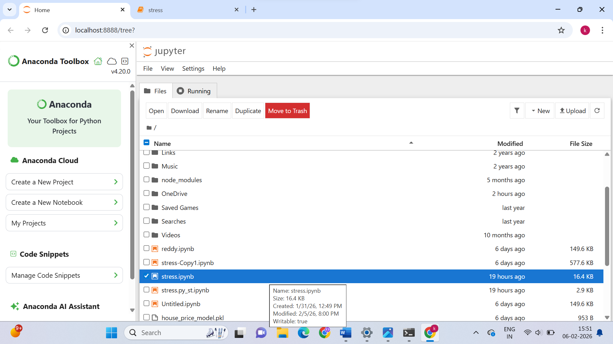
Step :2
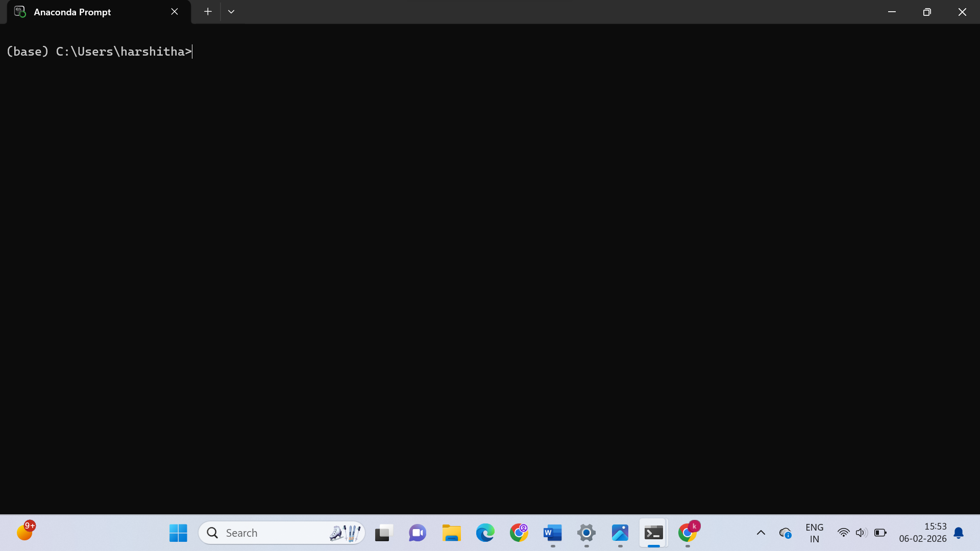

Step :3
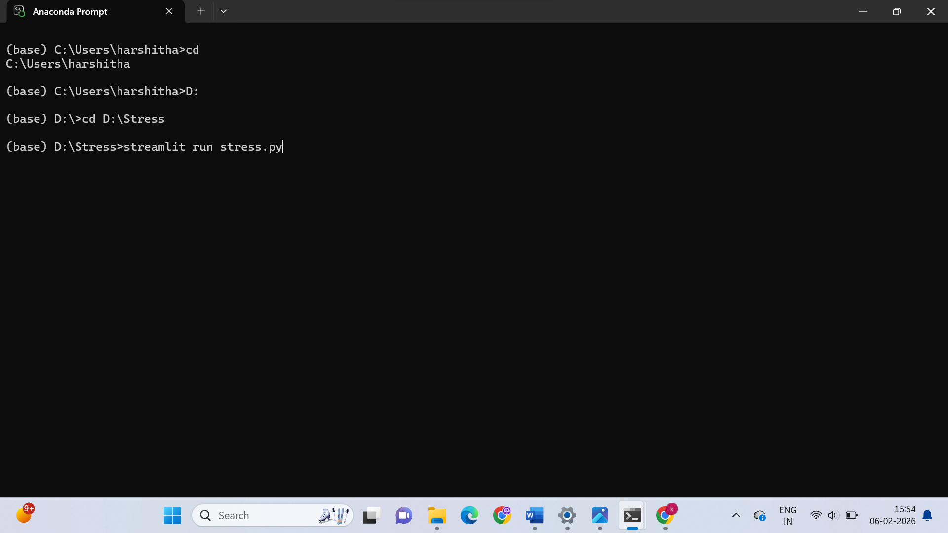
Step :4
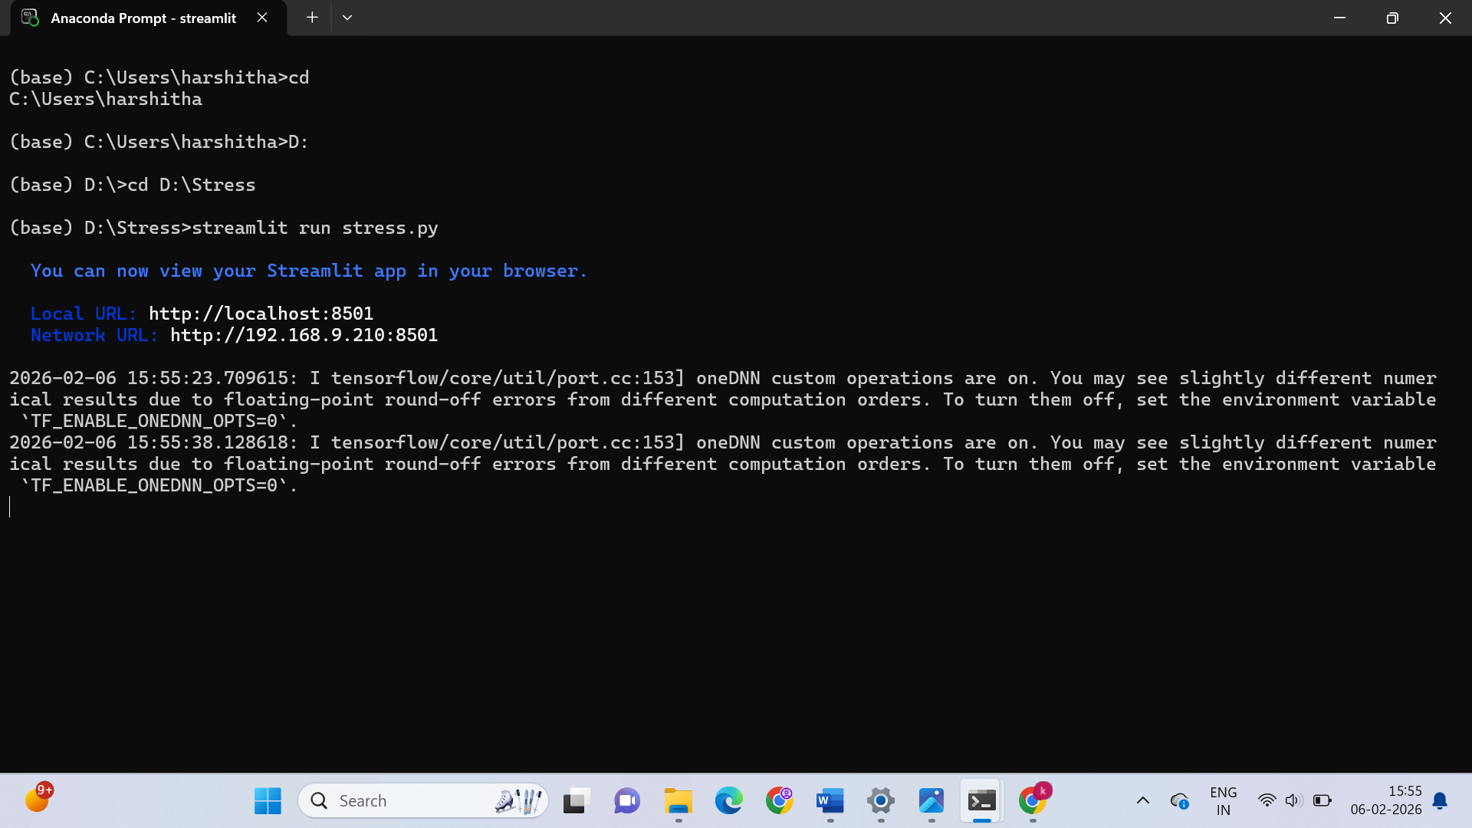

Step : 5
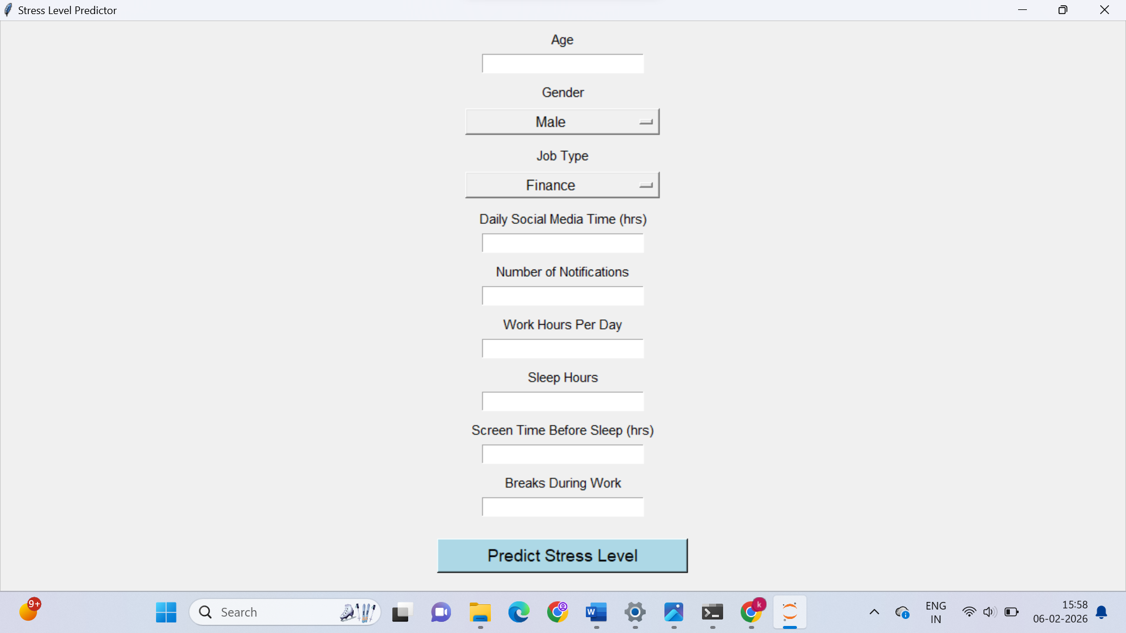
Step :6
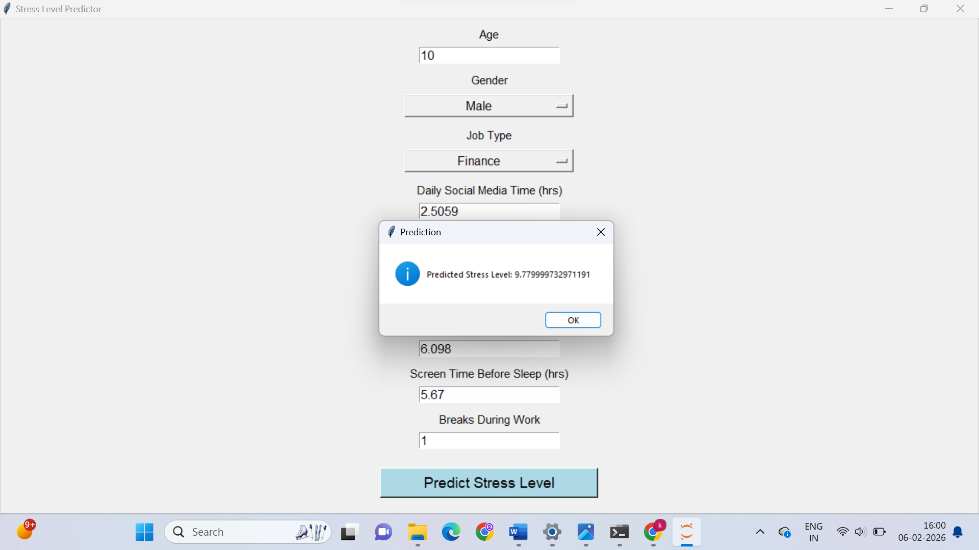

CONCLUSION
The Stress Level Prediction System demonstrates the effective application of deep learning in mental health analytics. By analyzing multiple behavioral and lifestyle parameters, the system provides objective and data-driven stress level predictions.
The Streamlit-based interface ensures ease of use and accessibility. The project highlights the potential of artificial intelligence in early stress detection and wellness management. Overall, the system serves as a strong foundation for future research and development in AI-based mental health solutions.

FUTURE ENHANCEMENTS
Future enhancements may include integration with wearable devices to collect physiological data such as heart rate and sleep cycles. Personalized stress management recommendations and alerts can be added. Visualization dashboards can help users track stress trends over time.
Advanced deep learning models such as LSTM networks can be used to capture temporal patterns. Cloud deployment and mobile application support can further enhance accessibility. These enhancements can transform the system into a comprehensive mental health monitoring platform.

REFERENCES (IEEE STYLE)
[1] R. Lazarus and S. Folkman, Stress, Appraisal, and Coping, Springer, 1984.
[2] A. Shatte et al., “Machine Learning in Mental Health,” JMIR, 2019.
[3] T. Åkerstedt et al., “Sleep, Stress, and Work,” Journal of Sleep Research, 2014.
[4] I. Goodfellow et al., Deep Learning, MIT Press, 2016.
[5] Streamlit Inc., “Streamlit Documentation,” 2019.
[6] S. Russell and P. Norvig, Artificial Intelligence: A Modern Approach, Pearson, 2016.
[7] C. Bishop, Pattern Recognition and Machine Learning, Springer, 2006.
[8] J. Han et al., Data Mining: Concepts and Techniques, Morgan Kaufmann, 2012.
[9] WHO, “Mental Health at Work,” 2020.
[10] IBM, “AI in Mental Health,” 2021.
[11] Google, “AI for Well-Being,” 2022.
[12] Microsoft, “Digital Wellness and AI,” 2021.
[13] APA, “Stress in Modern Life,” 2020.
[14] Accenture, “AI-Driven Health Analytics,” 2020.
[15] McKinsey, “Mental Health and Productivity,” 2021.

